Dog Trap Ford Post Office N.S.W

Tony Curtis

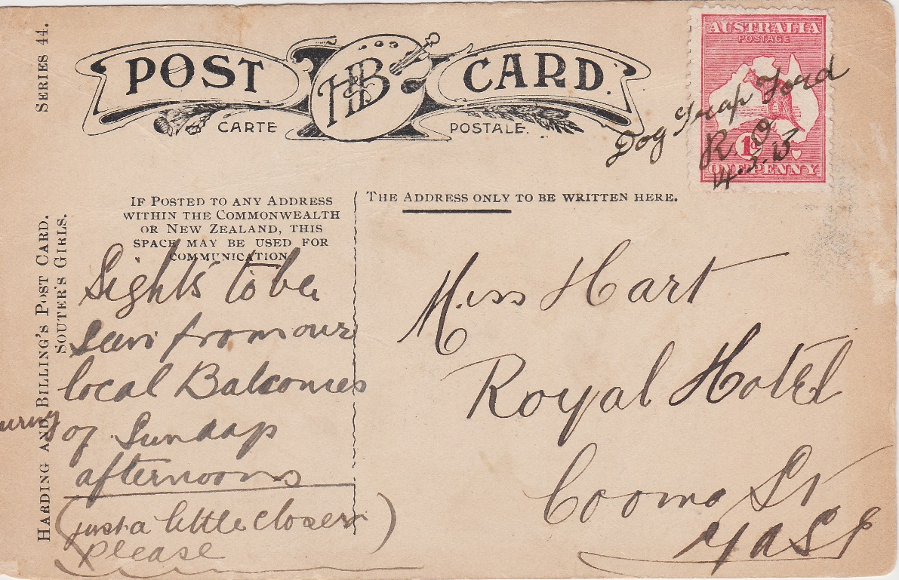
Figure 1 – 14 May 1913, Dog Trap Ford Receiving Office, ink manuscript cancellation tying 1d red Kangaroo to Harding and Billing’s postcard addressed to Miss Hart, Royal Hotel, Yass

There is little doubt that during the first decade and a half of the 20th Century, as a young woman, employed by the Mandelson family, managing hotels in the Yass and Queanbeyan districts and not unusually for that period, having an interest in postcards, Miss Matilda (Tilly) Hart would not have appreciated the value, her future legacy, in the form of a small postcard collection, would have to either the philatelic world or those with an interest in local history, a century later.
The postcard depicted at Figure 1, addressed to Ms Hart, at the Royal Hotel in Yass and bearing a black ink manuscript cancellation from the Dog Trap Ford Receiving Office, is the only recorded postal marking from this small post office, located approximately 20 miles South of Yass, New South Wales, which opened in 1907 and closed 23 years later. Additionally, the manuscript constitutes a very early cancellation on what was the first stamp issued by the Commonwealth in 1913, following the Federation of the Australian Colonies in 1901. Perhaps unusually, it does not bear a Yass arrival mark and may have been delivered directly to Ms Hart by the mail contractor. Whilst receiving office manuscript cancellations are generally scarce to rare, many, like Dog Trap Ford have not been seen.
Origins of the name – Dog Trap Ford
Contrary to modern folk law, the name ‘Dog Trap Ford’ appears not to have had anything to do with the trapping of wild dogs by the region’s early settlers. However, most likely had its origins in a mode of transport, popular in that era, a small horse drawn cart known as a dog trap. Smaller than the more well-known and larger pony trap, the dog trap was generally suited to the carriage of one or two persons, two wheeled and drawn by a single horse. The vehicle was reportedly more than useful in negotiating narrow tracks and crossings, all too common in the diverse Yass Valley terrain.
Location of Dog Trap Ford
The N.S.W. Government Gazette of 16 February 1883 (5), giving notice of the Proposed Resumption of Land for Road, clearly identifies the location of the Dog Trap Ford. The then land to be resumed was described as, a road from a reserved road within W. Davis’ 40 acres C.P. No.23, Parish of Umburra, County of Cowley, to road within R. Johnston’s 912 acres, Parish of Jeir, County of Murray, being an approach to the Dog Trap Ford of the Murrumbidgee River. The location and name are clearly marked on the old parish maps and the location appears to be consistent with the location of the current crossing from Cavan Road to the unnamed road on the ‘Carkella’ property, which joins Dog Trap Road (see Figure 3).
Whilst the current crossing, known locally as ‘Hyles’, is of more recent construction, it is highly probable that the original crossing, dating back to the mid 1800’s, was at the same location or in very close proximity. It is believed that the original construction was destroyed in a major flood almost one hundred years ago and was probably repaired or replaced several times in the interim.
Interestingly, Dog Trap Ford was also marked on a map produced in respect of the Sale by Public Tender of Jeir Station and the holdings of the estate of Robert Johnston in November 1908 (4).
A low level, livestock, wet crossing, located further upstream and known as ‘Dog Trap Crossing’, is not to be confused with ‘Dog Trap Ford’, from whence the post office drew its name.
A subsequent N.S.W. Government Gazette of 7 August 1883 (6), notified a Road Opening in respect of part of a road from Yass to Mullion being, part of a road to the South Boundary of J. Terry’s 640 acres to the Dog Trap Ford of the Murrumbidgee River, Parishes of Boambolo, Nanima and Jeir, County of Murray.
Who was Matilda (Tilly) Hart
Born at Molong, N.S.W. in 1881, the daughter of a farmer, Thomas Bond Hart and Julia Ann Toole (Hart) (nee Adams), Miss Hart’s life beyond the period spanned by her postcard collection is somewhat of a mystery. Departing Yass in 1911, to open her own business in Orange, the Queanbeyan Age of Tuesday 4 April 1911 (3), reported a presentation being made by Mr. and Mrs. Mandelson and the boarders and employees at the Australian Hotel at Yass, to a capable and popular manager. However, given that the postcard in question is dated 1913, it would appear that Miss Hart had either returned to Yass at this stage or was visiting at the time of receipt of the postcard.
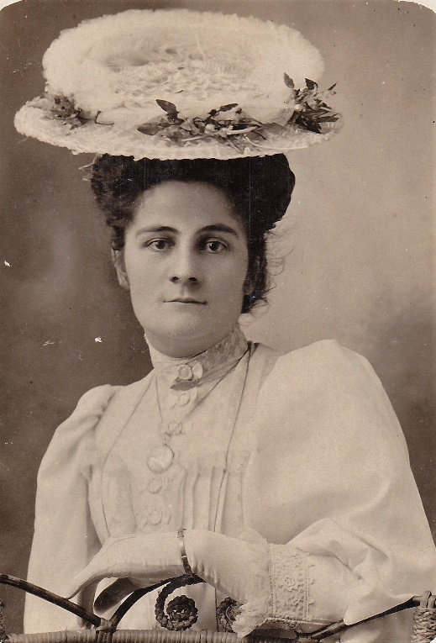
Figure 2 – Real photo postcard image of Miss Matilda (Tilly) Hart circa 1910 - 1915

Whilst Miss Hart may have periodically returned to Yass, the electoral rolls confirm that by 1930, she was a permanent resident of the town, residing at the Club House Hotel, where her occupation was listed as home duties. It appears that she remained in Yass until the time of her death in 1948.

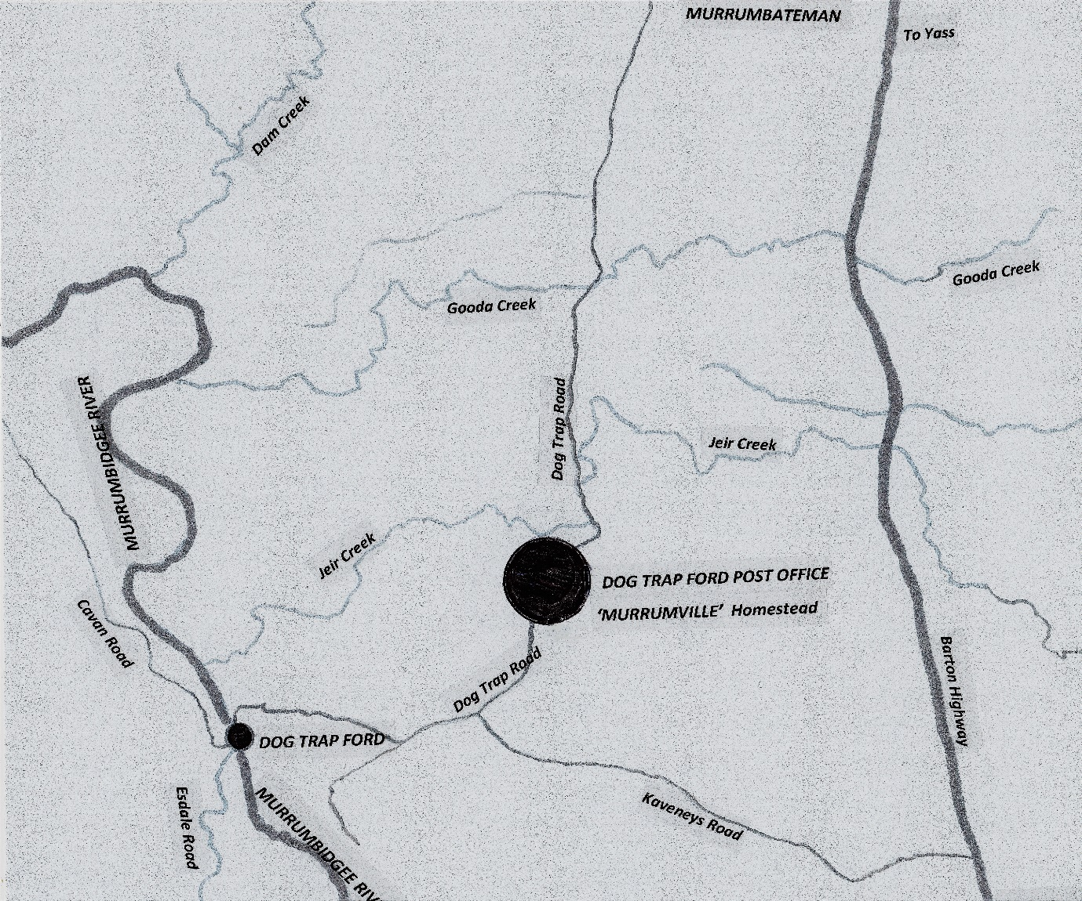
Figure 3 – Map identifying location of Dog Trap Ford on the Murrumbidgee River and the Dog Trap Ford Post Office at Murrumville Homestead, Dog Trap Road, Parish of Jeir, Yass Valley

Dog Trap Ford Post Office
The Dog Trap Ford Receiving Office opened on 22 July 1907, at the residence of George and Effie Clarke on Dog Trap Road, Jeir, approximately 20 miles from Yass. The Clarke’s were graziers and Effie was appointed Receiving Office Keeper.
Regrettably, early documentation concerning the establishment of the Office is not contained on the official post office file. However, it is interesting to note that in respect of the nearby Jeir Post Office, which for a period, was located at Jeir Station, George Clarke and Robert Johnston were both signatories to the Petition calling for its establishment.
At the time of the opening of Dog Trap Ford Receiving Office, the nearby Jeir Post Office had been relocated from Jeir Station back to Thomas McAuliffe’s ‘Elmside’ on the main Yass to Canberra Road, now the Barton Highway, where it had originally opened in February 1880.
Additionally, Jeir Station had entered into a Private Bag arrangement with Yass Post Office and Ledgerton Receiving Office had opened at Mullion, on the other side of the Murrumbidgee River. Undoubtedly, many residents located West of Jeir Station, through to the Murrumbidgee River and North to Gooda Creek and south to Wallaroo, particularly in the region of Yeumburra, would have appreciated the postal services offered by the Dog Trap Ford Receiving Office.
As a Receiving Office only, Dog Trap Ford provided for the acceptance and delivery of mail to residents in that locality, the receipt and despatch of mail bags and sale of postage stamps. The Office was not issued with a date stamp for cancelling mail. However, as evidenced in the example depicted (see Figure 1), mail was, at least for a period, cancelled in manuscript utilising black ink. The handwriting is unquestionably that of Effie Clarke, characteristics being similar in most respects to that contained in official post office correspondence on the Dog Trap Ford Post Office file, housed in the National Archives of Australia (see Figure 3).
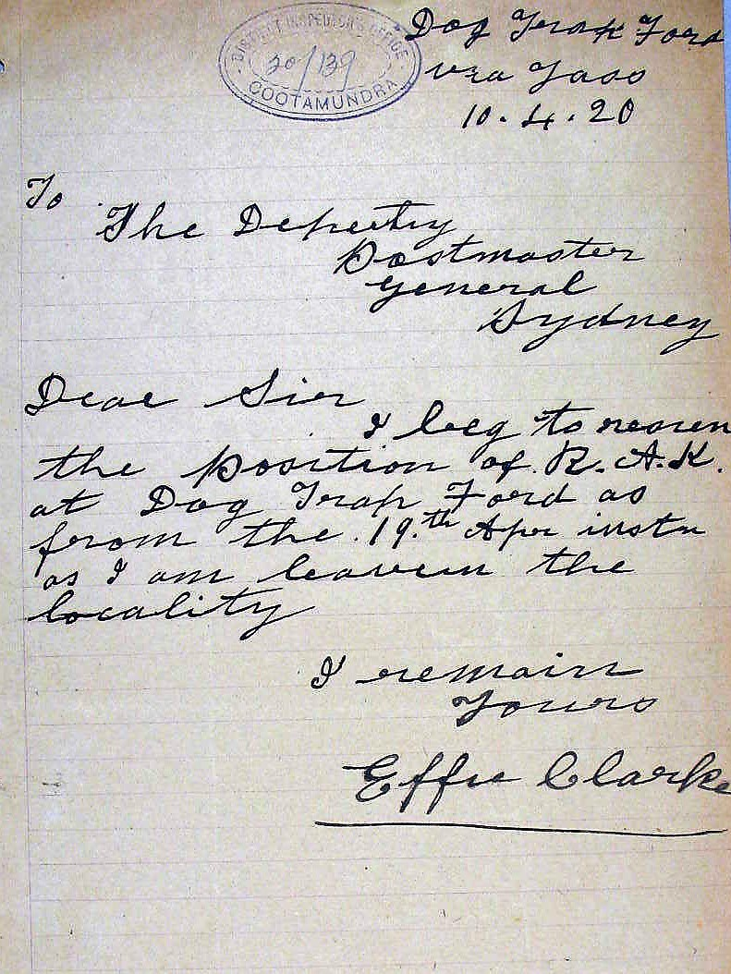
Figure 4 – Resignation of Effie Clarke contained on Dog Trap Ford Post Office Official File, National Archives of Australia
Effie Clarke continued in the role of Receiving Office Keeper at Dog Trap Ford until 10 April 1920, when she wrote to the Deputy Postmaster General notifying her intention to resign, as she was leaving the area (see Figure 3).
The Clarke’s property adjoined ‘Murrumville’, owned by Andrew Davis (see Figure 2), who was in the process of acquiring their property. As the only applicant, Davis successfully applied for the position of Receiving Office Keeper and commenced operating the Office from Murrumville homestead on 16 April 1920. George and Effie Clarke moved to Yass, where they lived out their retirement.
Andrew Davis’ term as Receiving Office Keeper spanned 9 years, during which time the Office was designated a non-official post office, following abolishment of the receiving office category of post office. Davis subsequently sold his property to Alfred Burgess, who was appointed Allowance Postmaster, Dog Trap Ford Post Office on 29 May 1929, being the only applicant for the role. Remuneration for the position at this time was 15 pounds 10 shillings per annum. The Office was operated from the same room at Murrumville homestead as utilised by Andrew Davis.
As with all smaller size post offices during this era, Dog Trap Ford was increasingly placed under greater scrutiny as austerity measures were being applied across the network. On 25 June 1930, the Deputy Director, Posts and Telegraphs, J.W. Kitto, wrote to the Postmaster, Dog Trap Ford, informing him that owing to the small number of residents being served by the Office, it was no longer considered to be a public necessity and it would close from 30 June 1930.
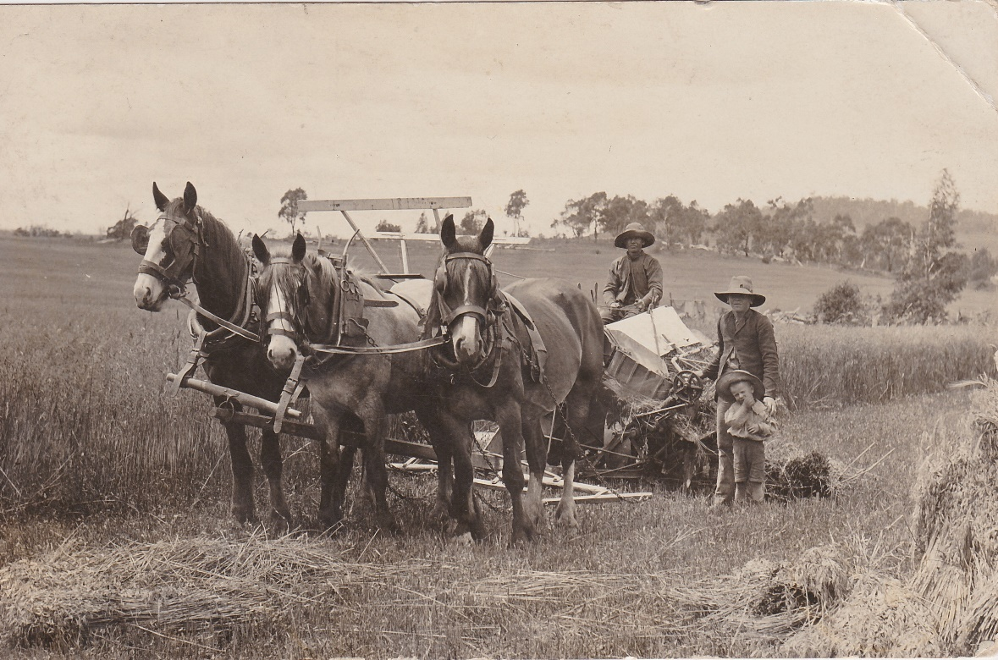
Figure 5 – Real picture postcard addressed to Miss Tilly Hart, c/o Mr Mandelson, Commercial Hotel, Queanbeyan from a family member, probably in the Molong area and mailed from a travelling post office, encapsulating the life of the Hart family member, as a young farmer in rural New South Wales.

Epilogue
Dog Trap Ford Post Office ceased operating 87 years ago and but for the Tilly Hart correspondence, few would have ever known of its existence, let alone have ever seen a postal marking from one of the Yass Valley’s small and long forgotten receiving offices.
Regrettably, I have not been able to establish the identity of the sender of the postcard or their connection with Miss Hart. Like so many aspects of Tilly Hart’s private life, this secret has been taken with her to the grave.
The Murrumville property is today owned and operated by Mr Frank Kaveney.

References;
- National Archives of Australia: SP32/1 DOG TRAP FORD
- National Archives of Australia: SP32/1 JEIR
- PRESENTATION. (1911, April 4). Queanbeyan Age (NSW : 1907 - 1915), p. 2. Retrieved May 14, 2017, from http://nla.gov.au/nla.news-article31378989
- Love, Arnold W & William Brooks & Co (1908). Jeir Station, Yass, N,S,W. : 18 miles from Yass, 27 miles from Queanbeyan, for sale by public tender, all tenders for purchase to be in the hands of the vendors on or before, 30th November, 1908. William Brooks & Co., litho, Sydney http://trove.nla.gov.au/version/34480707
- PROPOSED RESUMPTION OF LAND FOR ROAD UNDER 27TH SECTION OF ACT, 43 VICTORIA No. 29.—LAND DISTRICT OF QUEANBEYAN. (1883, February 16). New South Wales Government Gazette (Sydney, NSW : 1832 - 1900), p. 878. Retrieved May 14, 2017, from http://nla.gov.au/nla.news-article221661510
- FORMAL OPENING OF A PARISH ROAD. (1883, August 7). New South Wales Government Gazette (Sydney, NSW : 1832 - 1900), p. 4241. Retrieved May 14, 2017, from http://nla.gov.au/nla.news-article221656768

14 May 2017

